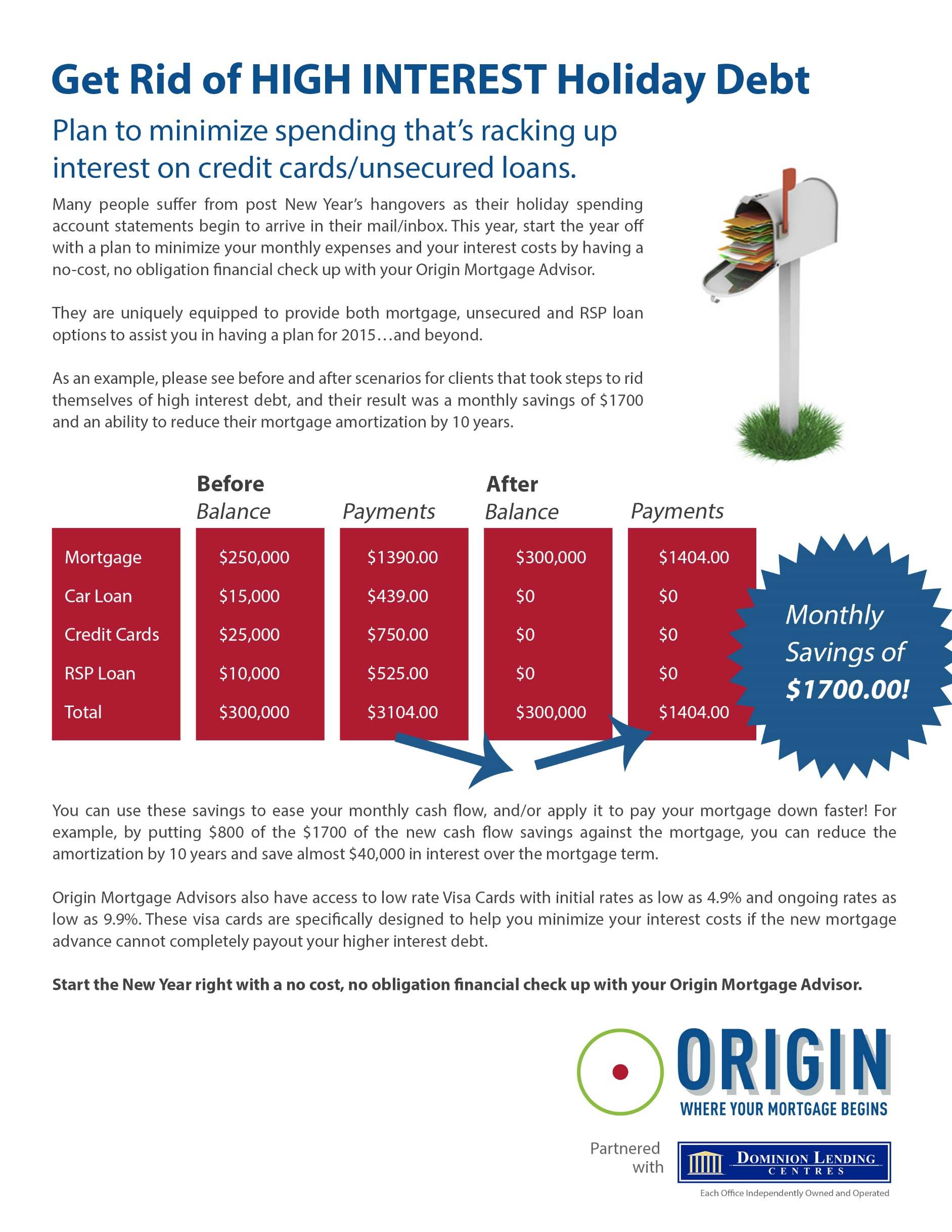

Agent Name

Position

Tel: 604.000.0000

Email: [agentname@originmortgages.ca](mailto:agentname@originmortgages.ca)

Website: www.agentname.ca